Artificial Intelligence Behavior Evaluation

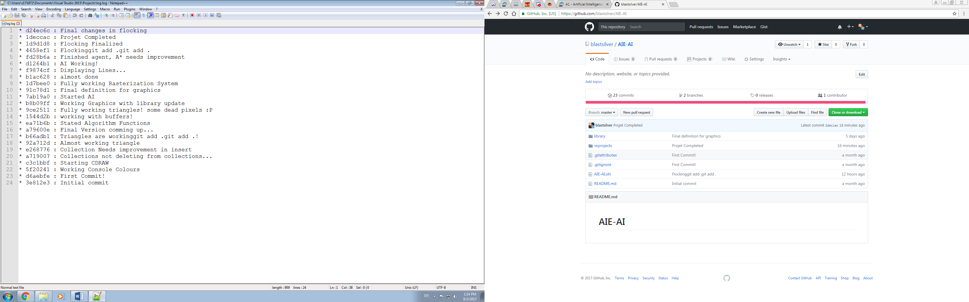Git commit log:

Most of the time in this project I have been working on a graphics API which would allow me to render different kinds of shapes on the windows console. I learned how to rasterize shapes in world coordinates and convert them to pixels in screen coordinates. I also been using a depth buffer to do some depth checking and got clipping working as well.

Later I implemented the flocking and a\* using my graphics class but I did not have time to implement what I wanted in the first place. I feel like I spent too much time working on the visual side of things that understanding the algorithms first. I think I need to better plan my assignments so I can achieve my goals. Despite that I am happy with the final result!

